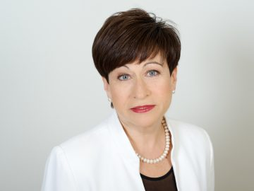

Prof. Dr. hab. oec. Inna Šteinbuka
Chair of the LAS EPPI Council
Full member of Latvian Academy of Sciences

Biography
Inna Šteinbuka is Professor, Director of the Master's degree programme "European Studies and Economic Diplomacy" at the University of Latvia. In 2018-2019 she was a special advisor to Vice President of the European Commission Valdis Dombrovskis. Since 2018 she was a member, and since December 2019 became Chair of the Latvian Fiscal Discipline Council. From 2011 to 2018 she has been the Head of the European Commission Representation in Latvia. She has been working at the European Commission since 2005 and was previously the Director of the Department of Economic and Regional Statistics, and the Department of Social and Information Society Statistics at Eurostat. Prior to joining the European Commission, she has been Chair of the Public Utilities Commission of Latvia and Senior Advisor to the Executive Director of Nordic - Baltic constituency at the International Monetary Fund in Washington D.C. She has previously held various positions at the Ministry of Finance. She is a Member of the "Economists Association 2010". Inna Šteinbuka is full member of the Latvian Academy of Sciences. In 2008 Inna Šteinbuka was awarded with the Order of the Three Stars for her achievements in finance and economics.

